LAB SESSION: 09
(Circular Linked List – Insertion and Traversal)

Class For Node Function for display
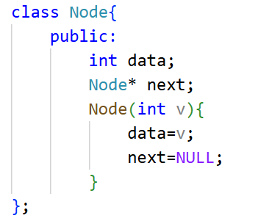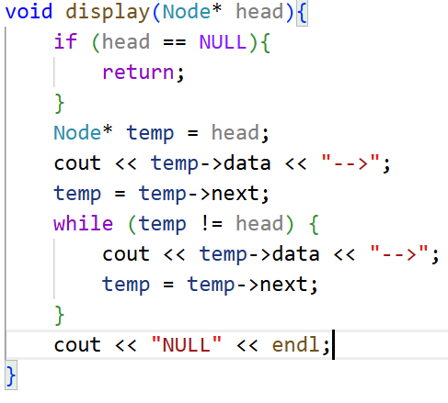

- Implement an insertAtPosition() function for a CLL.
CODE:
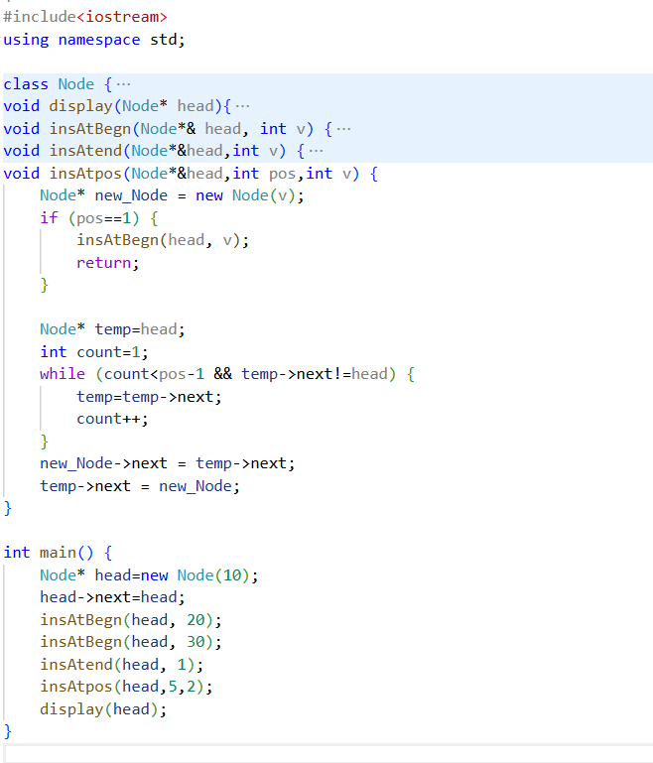
Output:

- Modify the code to work with a doubly circular linked list.
CODE:
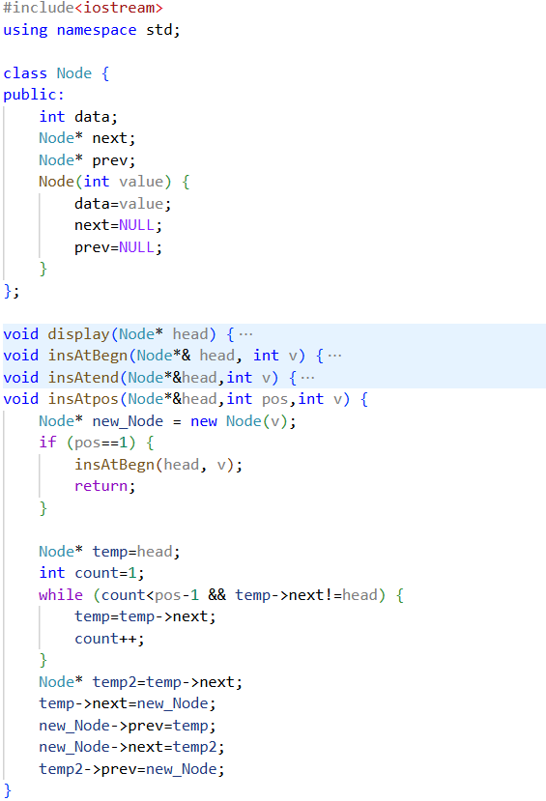
int main() {
Node* head=new Node(10);
head->next=head;
head->prev = head;
insAtBegn(head, 20);
insAtBegn(head, 30);
insAtend(head, 1);
insAtpos(head,2,2);
display(head);
}

OUTPUT:

- Write a function to search for a value in the CLL.
CODE:
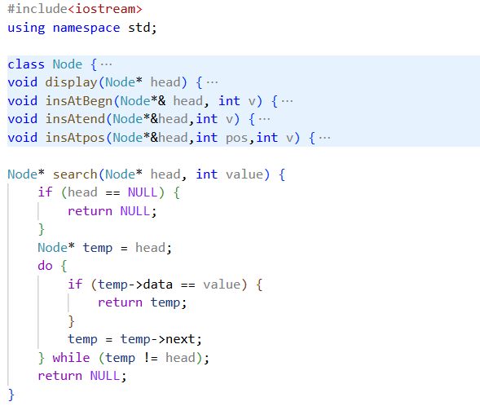
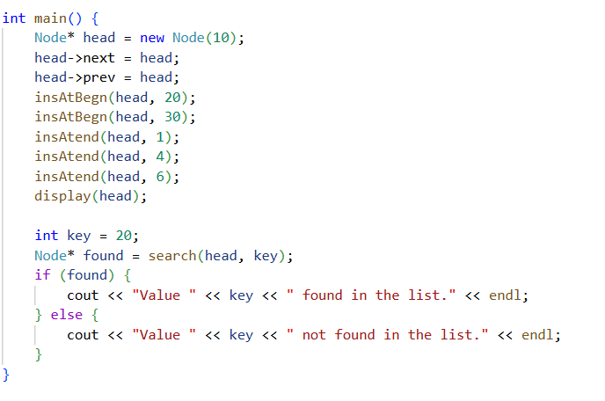

OUTPUT
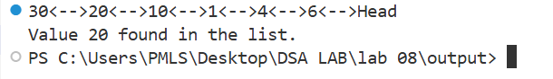
- Implement a delete function for the first node in the CLL.
CODE:
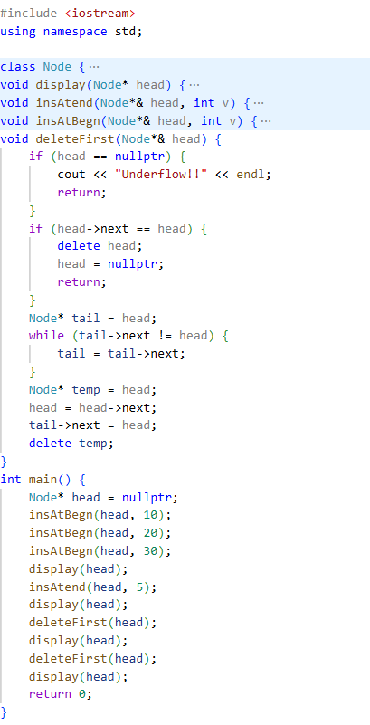

OUTPUT
